Classifying and understanding matter
1. Sort the following objects into groups, either solids liquids or gasses. If you don’t think an object is made of matter then classify it as ‘not matter’. Then write them into the table below. Make sure to have an explanation to justify why you put them in each group

- Drinking water
- Apples
- Olive oil
- Steam
- Light from the sun
- Toothpaste
- Milo powder
- Jelly
- Sand
- Paper
- Helium
- Electricity
- Rocks
- Honey
- Fire
- Coca-Cola
- Play dough
- Clouds

Solids | Liquids | Gasses | Not matter

2. Paper is a common material that we all have used.
a. Is paper a solid, liquid or gas?
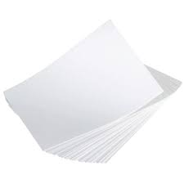
b. If you had a special magnifying glass that allowed you to see inside the paper to look directly at the smallest materials or particles that made it up, what do you think they would look like? Is there anything holding them together? How would they be arranged to form the paper that we see? Draw a diagram to show what you think this arrangement of the matter within the paper would look like.


c. Paper can be torn into pieces. Show what you think is happening to the matter when the material is being torn.

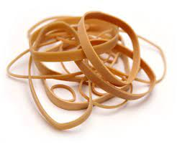
3. Rubber bands are another common material that we use. Like paper, rubber is a material made of matter. Draw a diagram of what you think the material or particles look like (their arrangement) when they are not being stretched and what they look like (their arrangement) when they are being stretched.

